Overview
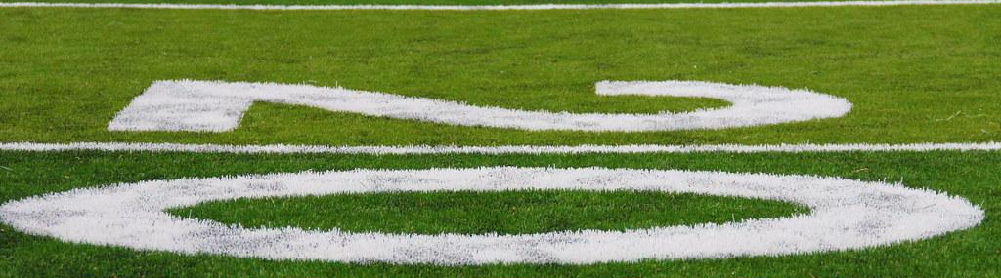

Falcons Schedule

Calendar event

Calendar
List the key activities for each day

Chicago Falcons @ St. Louis, Saturday, March 28, 2026  Place  - Chicago Falcons at St. Louis  - Falcons 3:00pm | Fox River Raiders @ Chicago Falcons, Saturday, April 4, 2026  Columbus Park  - Fox River Raiders at Chicago Falcons  - Chicago Falcons 3:00pm | Joliet Bucs at Chicago Falcons, Saturday, April 11, 2026  Columbus Park  - Joliet Bucs at Chicago Falcons 3:00pm
Day 4  Place  - Activity 10  - Activity 11  - Activity 12 | Day 5  Place  - Activity 13  - Activity 14  - Activity 15 | Day 6  Place  - Activity 16  - Activity 17  - Activity 18

Day 1

Day 1

Date

Attendees

Group | Primary contact | Phone number | Availability
Group 1 | Person | (000) 000-0000
Group 2 | Person | (000) 000-0000
Group 3 | Person | (000) 000-0000
Group 4 | Person | (000) 000-0000

Activity 1
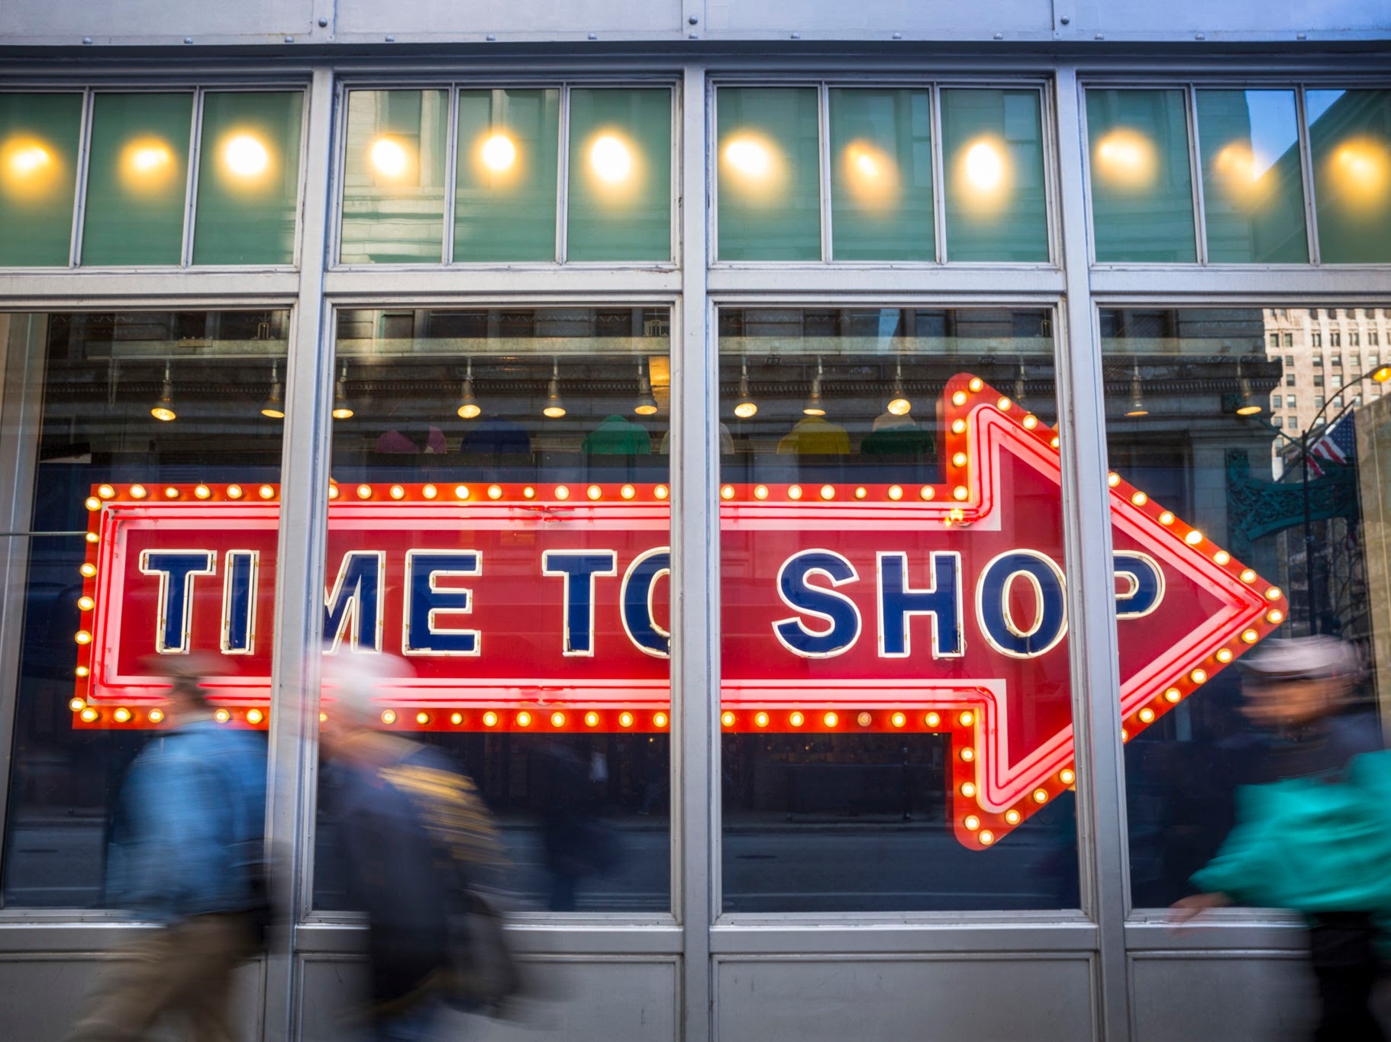

Location | Place
Time | Date
Duration
Travel time
Transportation | >>
Priority

Add details including the type of activity, directions, or other information guests need to know to participate

Activity 2
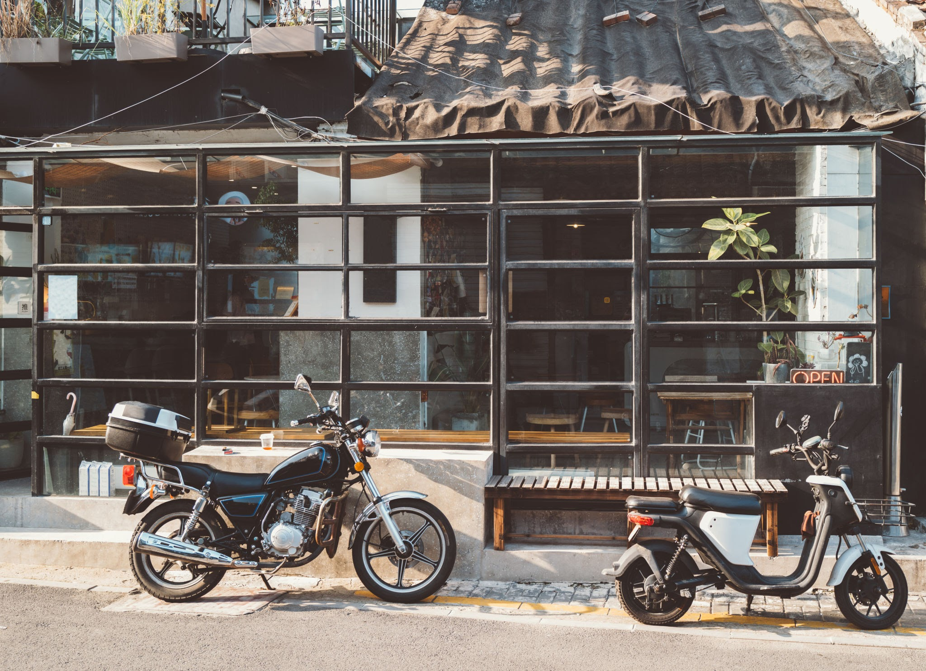

Location | Place
Time | Date
Duration
Travel time
Transportation
Priority

Add details on the type of activity, directions, or other information guests would need to know to participate in the activity

Activity 3
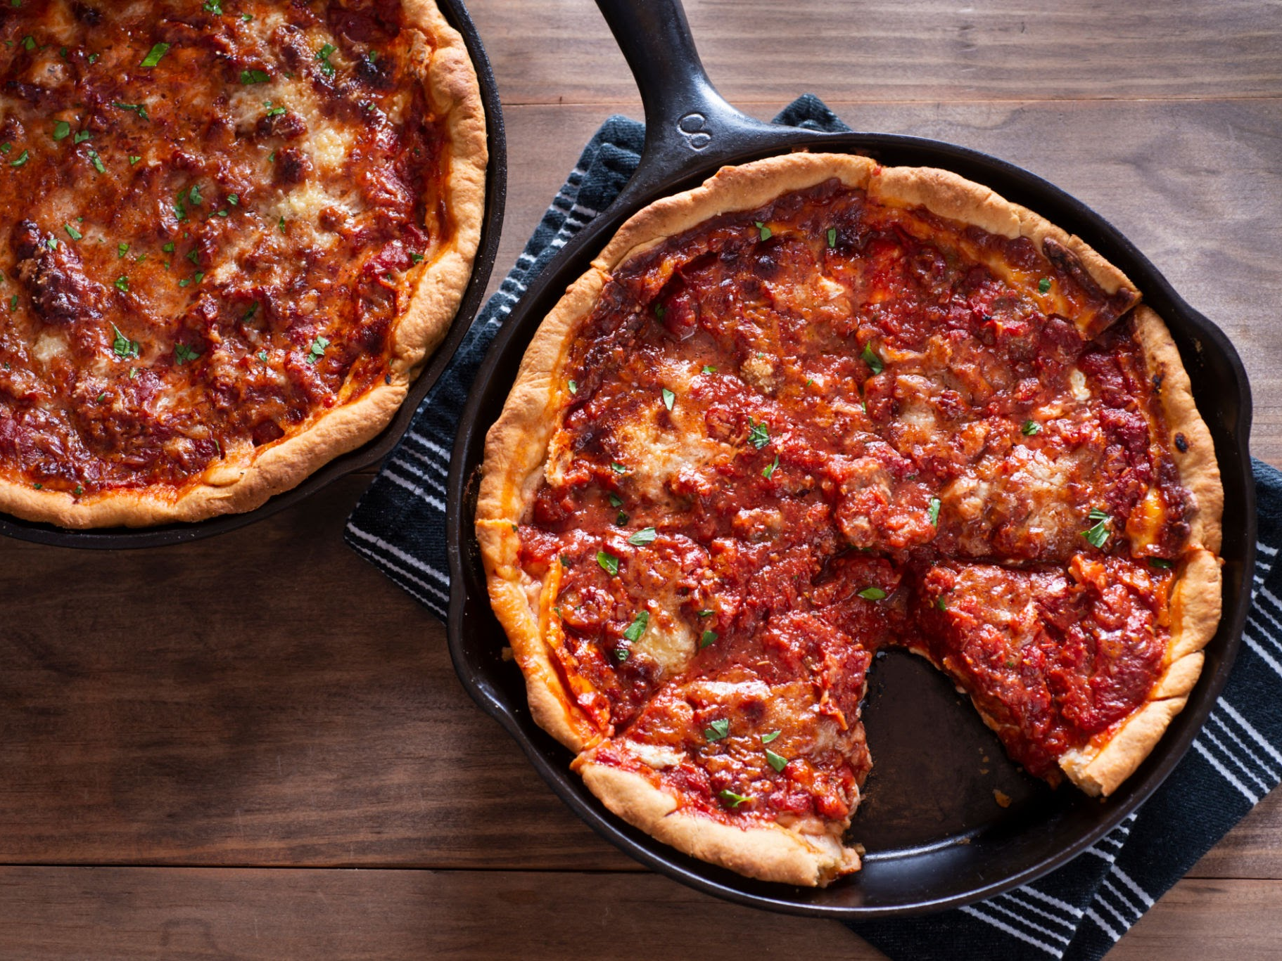

Location | Place
Time | Date
Duration
Travel time
Transportation
Priority

Add details on the type of activity, directions, or other information guests would need to know to participate in the activity

Accommodation
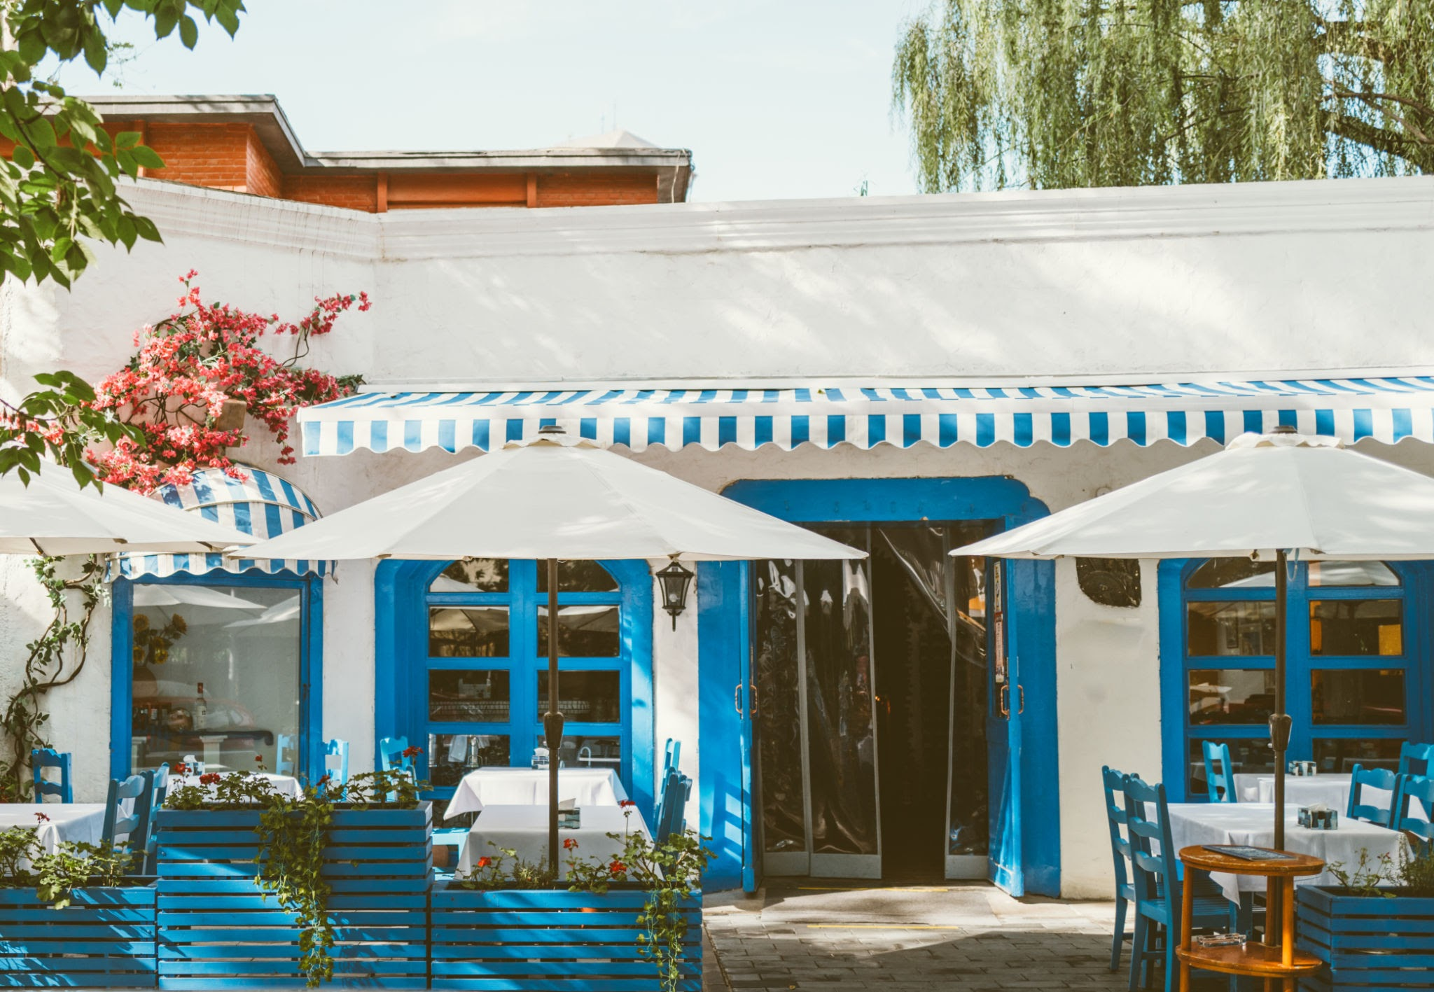

Residence | Place
Check-in | Date
Check-out | Date
Booking ID | #000000

List any important accommodation details

Day 2

Day 2

Date

Attendees

Group | Primary contact | Phone number | Availability
Group 1 | Person | (000) 000-0000
Group 2 | Person | (000) 000-0000
Group 3 | Person | (000) 000-0000
Group 4 | Person | (000) 000-0000

Activity 4
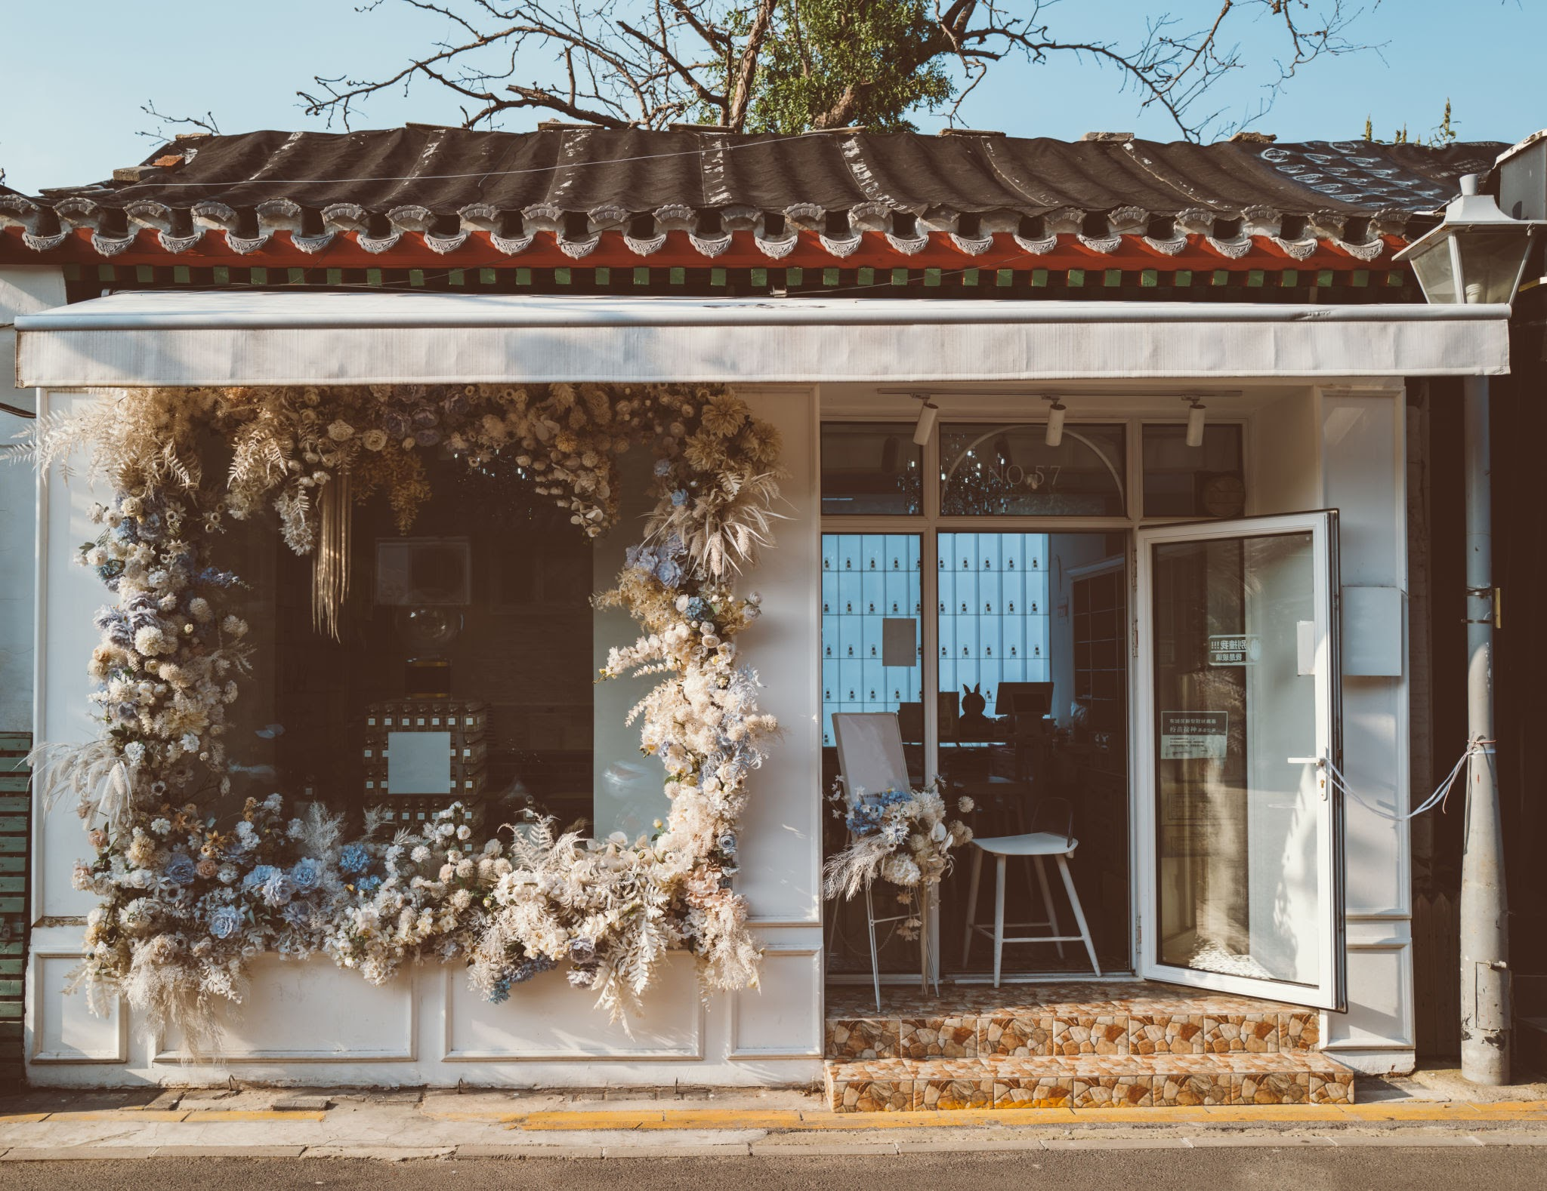

Location | Place
Time | Date
Duration
Travel time
Transportation | >>
Priority

Add details including on the type of activity, directions, or other information guests would need to know to participate in the activity

Activity 5
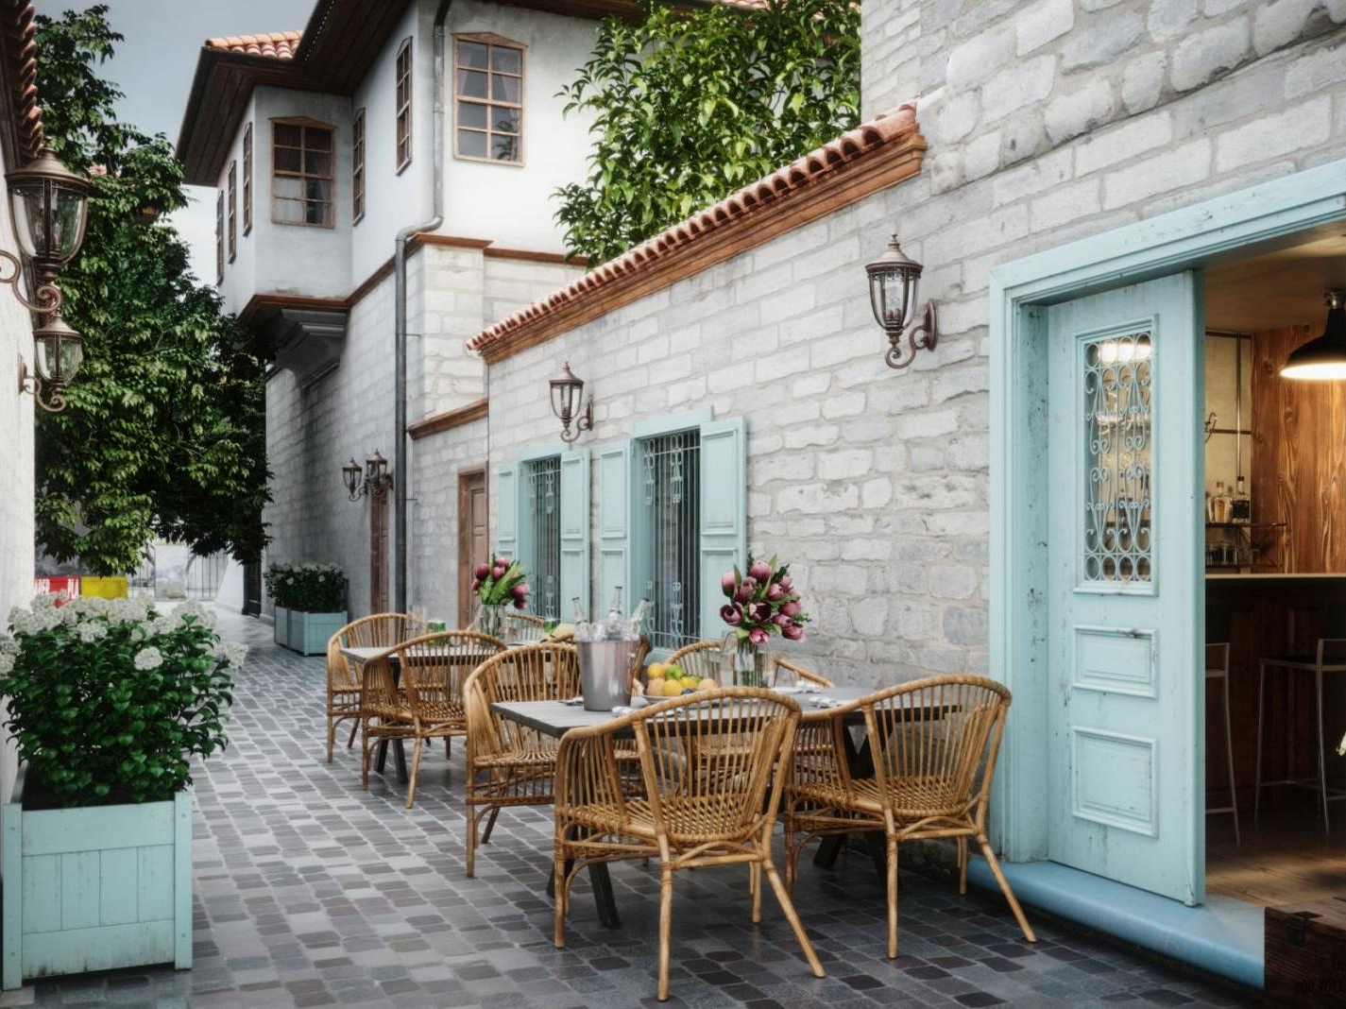

Location | Place
Time | Date
Duration
Travel time
Transportation
Priority

Add details on the type of activity, directions, or other information guests would need to know to participate in the activity

Activity 6
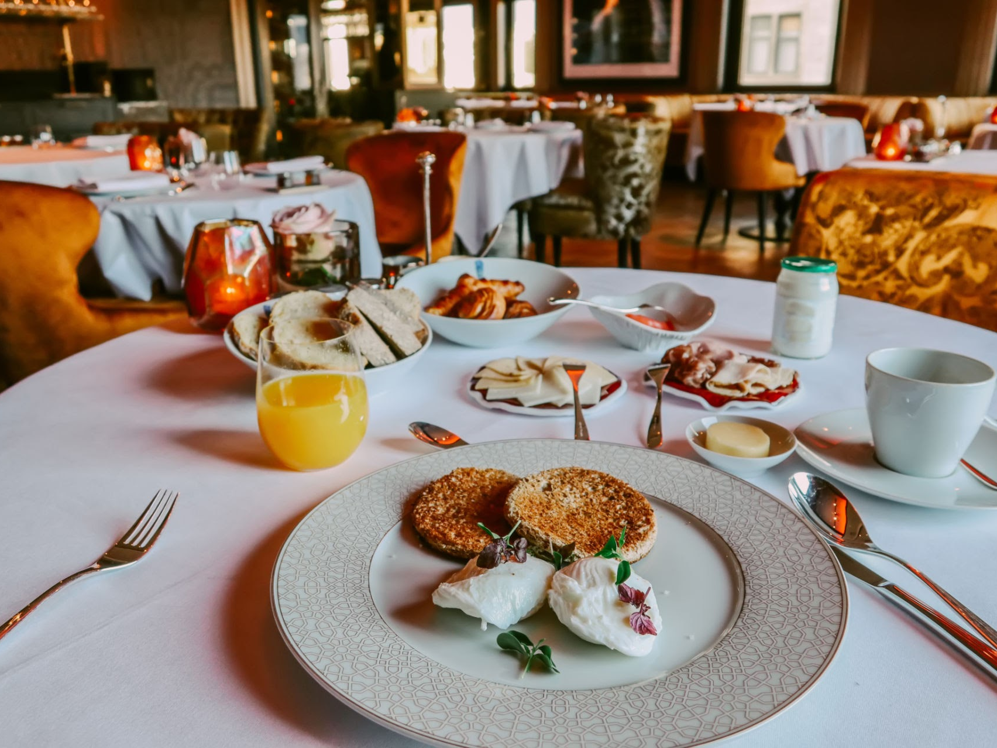

Location | Place
Time | Date
Duration
Travel time
Transportation
Priority

Add details on the type of activity, directions, or other information guests would need to know to participate in the activity

Accommodation
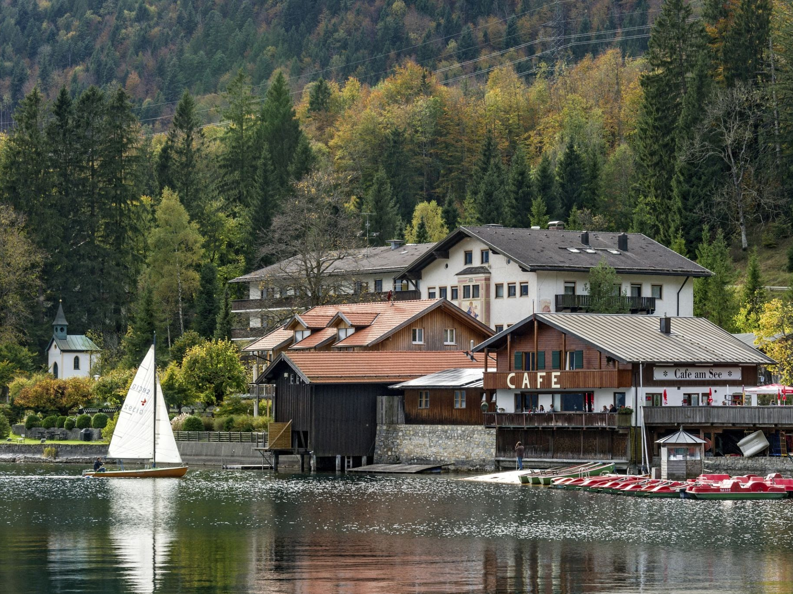

Residence | Place
Check-in | Date
Check-out | Date
Booking ID | #000000

List any important accommodation details

Packing list

Packing list
Calendar event

General:
  - Passport
  - Get a suitcase from storage
  - RSVP for dinner

Day 1:
  - Swimsuit
  - Sunglasses
  - Sunscreen
  - Water bottle
  - Towels
  - Change of clothes
  - Hat
  - Sandals

Day 2:
  - Warm waterproof jacket
  - Long sleeve shirt
  - Thermal layer
  - Warm pants
  - Scarf
  - Wool hat
  - Socks
  - Gloves
  - Boots
  - Lip balm
  - Sunglasses

